Part Number:

PT767-35110 (B-CAB REGULAR BED)

PT767-35111 (C-CAB REGULAR BED)

PT767-35112 (D-CAB SHORT BED)

PT767-35113 (D-CAB LONG BED)

Kit Contents
Item # | Quantity Reqd. | Description
1 | 1 | Right Side Step
2 | 1 | Left Side Step
3 | 1 | Hardware Bag
Hardware Bag Contents
Item # | Quantity Reqd. | Description
1 | 12 (C & D Cab) | 8mm x 30mm x 1.25mm Bolts
2 | 12 (C & D Cab) | Lock Washers
3 | 6 (C & D Cab) | Round Flat Washers
4 | 6 (C & D Cab) | Flat End Washers
5 | 8 (B Cab) | 8mm x 30mm x 1.25mm Bolts
6 | 8 (B Cab) | Lock Washers
7 | 4 (B Cab) | Round Flat Washers
8 | 4 (B Cab) | Flat End Washers
9 | 1 | Installation Instructions
Additional Items Required For Installation
Item # | Quantity Reqd. | Description
1
Conflicts
Genuine Running Boards:
C-CAB PN: PT212-35052
D-CAB PN: PT212-35054
Recommended Tools
Personal & Vehicle Protection | Notes
Eye Protection
Special Tools | Notes
None
Installation Tools | Notes
Socket/Ratchet | 13mm
Torque Wrench | 19.5 N.m (14.5 ft-lbf)
Tape Measure
Screwdriver | Flat Head
Special Chemicals | Notes

PT767-35120 (C–CAB REGULAR BED) CHROME
PT767-35121 (D-CAB SHORT BED) CHROME
PT767-35122 (D-CAB LONG BED) CHROME

General Applicability
2005 and newer Tacoma

Recommended Sequence of Application
Item # | Accessory
*Mandatory
Vehicle Service Parts (may be required for reassembly)
Item # | Quantity Reqd. | Description
1
Legend
STOP: Damage to the vehicle may occur. Do not proceed until process has been complied with.
OPERATOR SAFETY: Use caution to avoid risk of injury.
CAUTION: A process that must be carefully observed in order to reduce the risk of damage to the accessory/vehicle and to ensure a quality installation.
TOOLS & EQUIPMENT: Used in Figures calls out the specific tools and equipment recommended for this process.
REVISION MARK: This mark highlights a change in installation with respect to previous issue.
SAFETY TORQUE: This mark indicates that torque is related to safety.

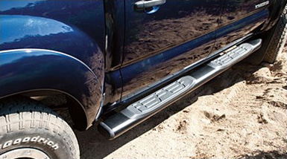

Care must be taken when installing this accessory to ensure damage does not occur to the vehicle. The installation of this accessory should follow approved guidelines to ensure a quality installation.

These guidelines can be found in the "Accessory Installation Practices" document.

This document covers such items as:-
- Vehicle Protection (use of covers and blankets, cleaning chemicals, etc.).
- Safety (eye protection, rechecking torque procedure, etc.).
- Vehicle Disassembly/Reassembly (panel removal, part storage, etc.).
- Electrical Component Disassembly/Reassembly (battery disconnection, connector removal, etc.).

Please see your Toyota dealer for a copy of this document.

Install the Driver Side Step.
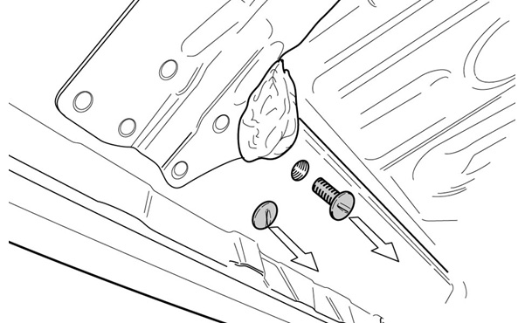
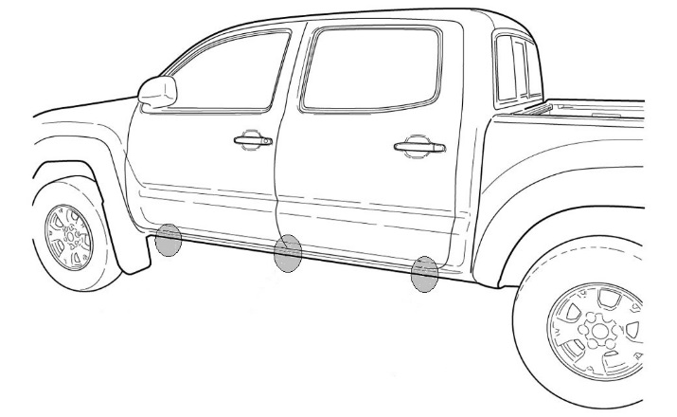
  - Remove the six (6) (for C & D-cab) or the four (4) (for B Cab) plastic screws located in the side step mounting holes under the vehicle and discard (Fig. 1-1 & Fig. 1-2).
Fig. 1-2
Flat head screwdriver
Fig. 1-1

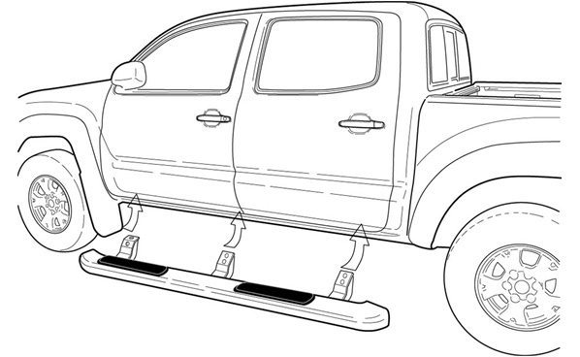
  - Place the side step under the vehicle and line up the mounting holes on the brackets with the mounting holes on the vehicle (Fig. 1-3).
Fig. 1-3

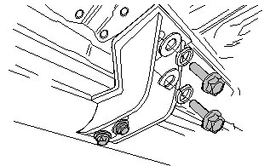
  - By hand, place three (3) flange bolts with one (1) lock washer and one (1) round flat washer per bolt into the mounting holes that are towards the inside of the vehicle and hand tighten (Fig. 1-4).
Fig. 1-4
  - By hand, place three (3) flange bolts with one (1) lock washers and one (1) flat end washer per bolt into the mounting holes that are towards the outside of the vehicle and hand tighten.
NOTE: Ensure that the flat end of the washer is parallel to the bend line of the bracket (Fig. 1-4).
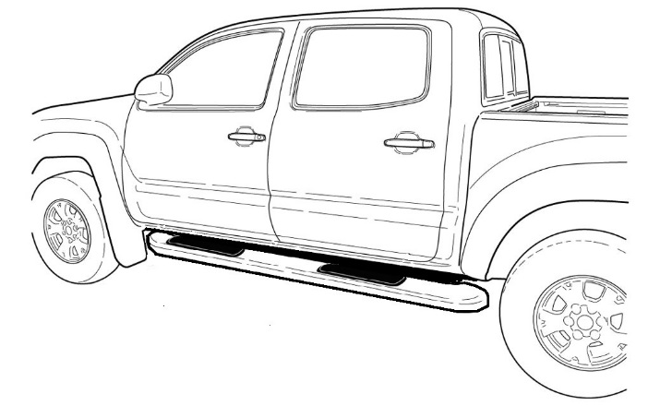
  - Align the tube so that it is rearward on the vehicle (Fig. 1-5). The bolts that are pre-installed that hold the brackets to the tube are only hand tight to allow for easy loosening if required to aide alignment. Ensure that each bracket is evenly moved rearward.
Fig. 1-5

  - Tighten and torque all six (6) or four (4) flange bolts on the vehicle to 19.5 Nm (14.5 ft-lbf) (Fig. 1-6).
Fig. 1-6
13mm socket & torque wrench
Torque: 19.5 Nm (14.5 ft-lbf)
  - Tighten and torque all six (6) or four (4) flange bolts on the tube to 19.5 Nm (14.5 ft-lbf) (Fig. 1-6).

Torque: 19.5 Nm (14.5 ft-lbf)

Install the Passenger Side Step.
  - Repeat the same process as driver side.

Accessory Function Checks
Tube alignment

Vehicle Appearance Check
After accessory installation and removal of protective cover(s), perform a visual inspection.

Tubes should be aligned so that they are centered on the vehicle

Ensure no damage (including scuffs and scratches) was caused during the installation process.
(For PPO installations, refer to TMS Accessory Quality Shipping Standard.)

